CCNP Lab 2

The purpose of this lab was to build off what I did in the previous lab. The previous lab was to set up single-area OSPF on 5 routers. This time, the concept that I am taught here is setting up multi-area OSPF for 6 routers. In single-area OSPF, adding a 6th router is easy—just copy and paste a router configuration into a new notepad file, then modify it slightly to fit what I would need for the 6th router. However, because I am using multiple areas, I need to change the area value for most routers and still allow them to communicate with each other and advertise their networks.

Some background of this lab. **O**pen **S**hortest **P**ath **F**irst is a way for routers to talk to each other and say to each other what they are connected to. Normally, routers can only see what they are physically connected to, and nothing else, so they can only see their own networks. This means that trying to connect to a network that is not directly connected to the router will fail because the router does not know how to get there. OSPF allows routers to say what networks are attached to them, so all routers within that OSPF area can see each other’s networks, allowing traffic to jump between them. Last time, I used single-area OSPF, which works well for small or medium offices. However, with large or very large networks, a single area will not cut it. This is because having every router on a single area can introduce problems like overwhelming routers with an insane number of unnecessary IP routes. The way to fix this is to split OSPF into multiple areas. It is recommended to set area 0 as the backbone and other networks will have areas 1, 2, etc. These other areas will be added to each branch of the overall network, giving each router only the routes that they need.

In summary, I set up 6 routers and enabled OSPF and OSPFv3 on all 6 of them, so that they could all communicate with one another and the PCs on either end of the networks. This time, I multiple areas. I used the OSPF and OSPFv3 areas 0, 1, and 2.

Configurating multi-area OSPF and OSPFv3 is like single-area OSPF and OSPFv3. The only difference is that instead of setting all router interfaces to area 0, you set it to something else, like say 1. The commands are still the same though:

ipv6 ospf <process-id> area <area #>

or

ip ospf <process-id> area <area #>

depending on the IP version.

This enables OSPF and OSPFv3 for the given process ID and area. Like last time, OSPFv2 needs a network, while OSPFv3 does not.

My network diagram is a Packet Tracer file, and while I cannot send the .pkt file directly, I can send a screenshot of the network diagram. This is what it looks like:

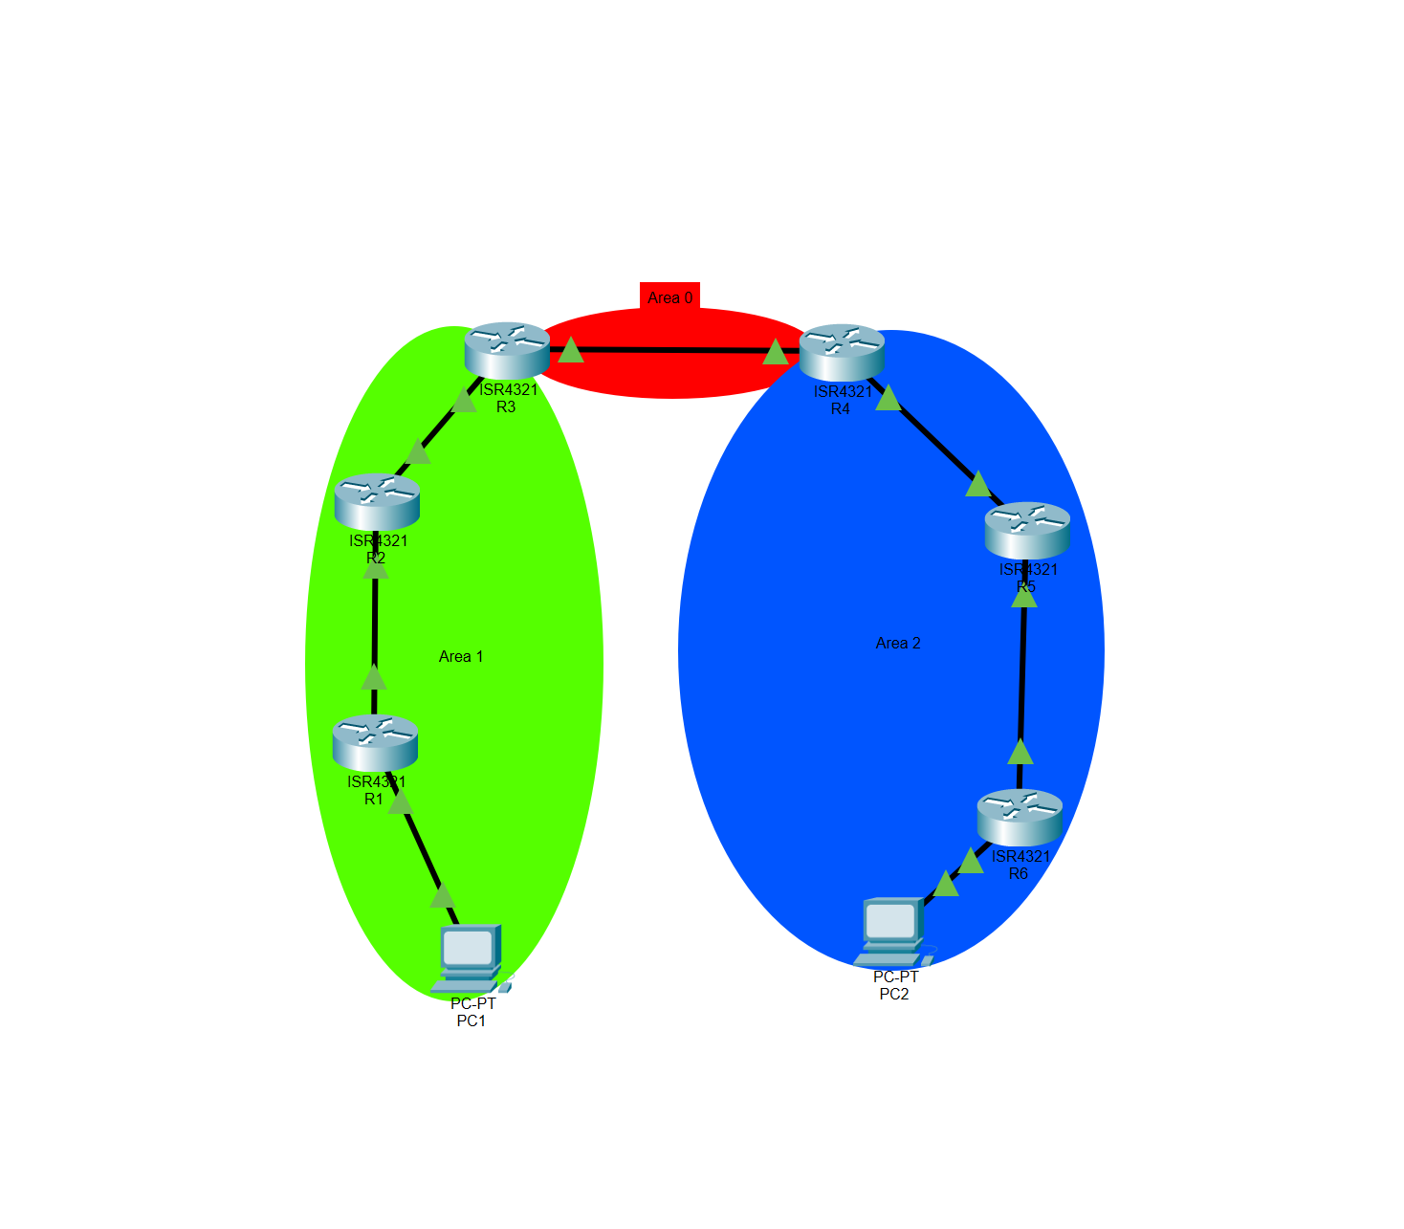

As you can see, just R3 and R4 are connected via area 0, while all other ports and routers are connected via areas 1 or 2.

My configurations are on 6 separate Word documents, one for each router, and I will send them all when I turn it in for the same reason as the Network Diagram. However, I can show a screenshot of the ping and traceroute from one end device to the other to show that multi-area OSPF and OSPFv3 was working properly:

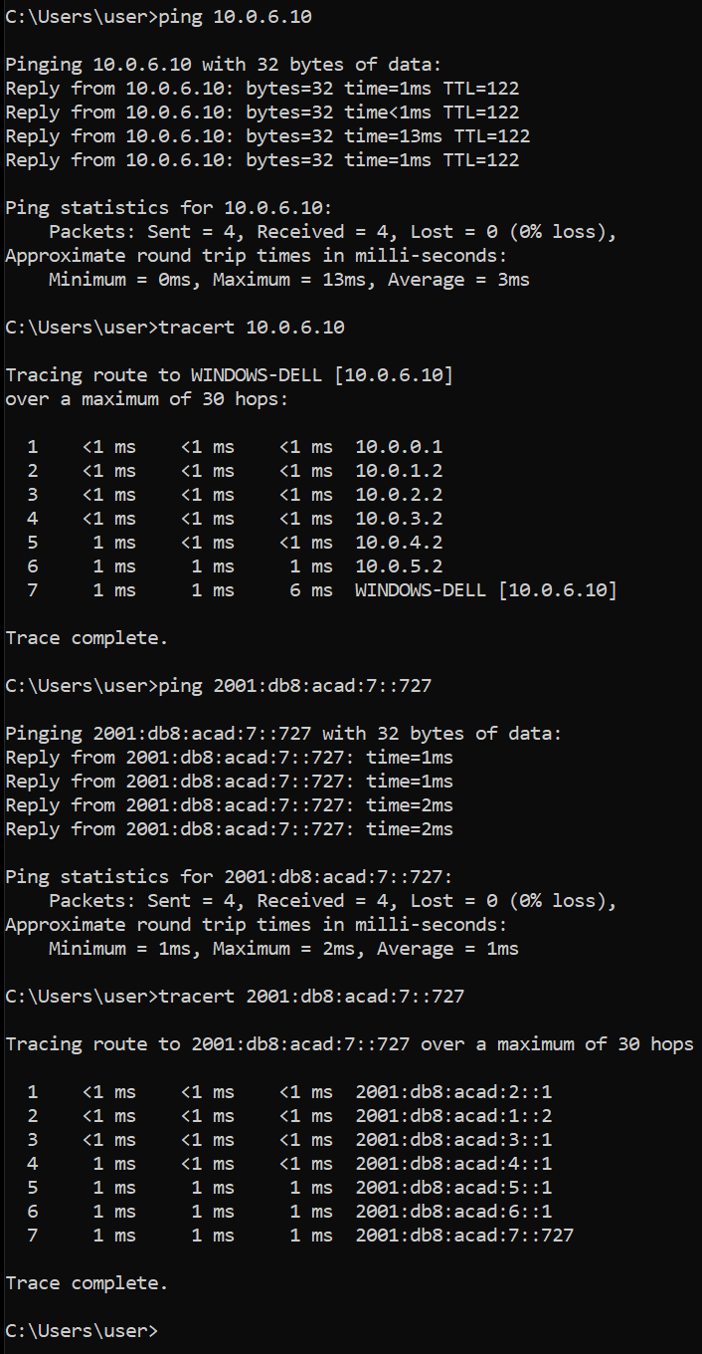

Since my configuration file is a slightly modified version of my first lab, I did not have very many problems with the lab itself, and I got it done in a day or two. I did have one problem though. All my OSPF networks had “O IA” on them (meaning OSPF inter area), suggesting that all my routers were on different OSPF areas. This was because I had an interface of R2 and R5 set to area 0. Because R1 and R6 saw R2 and R5, along with their own networks as directly connected networks, R1 and R6 only had directly connected routes (C and L) or O IA routes. I fixed this by making the only area 0 network a point-to-point network from R3 to R4, and everything else is set to areas 1 or 2. The same issue occurred with OSPFv3, though the IPv6 route name for inter area OSPFv3 is “OI.” I solved that issue in the same way as IPv4.

In conclusion, this lab was to set up inter-area OSPF and OSPFv3 on 6 routers, and all devices connected should be able to communicate with each other on the network. There was a small issue where all IP routes were OSPF inter-area or directly connected, but that was easy to fix. I learned how to set up multi-area OSPF and saw how it differs from single-area OSPF. It was interesting to see how the IP routes changed and see how different areas interacted with each other.